**Ideation Phase BRAINSTROM & IDEA PRIORITIZATION**

|  |  |
| --- | --- |
| Date | 25 OCT 2022 |
| Team ID | PNT2022TMID15704 |
| Project Name | Real time communication system powered by AI for specially abled |
| Maximum Marks | 2 Marks |

Problem Statement:

Now a days there are many peoples living with the disabilities of hearing and vocal.

Communicate with normal people using AI.

**Brainstorm & Idea:**

**Dhanalakshmi.p**

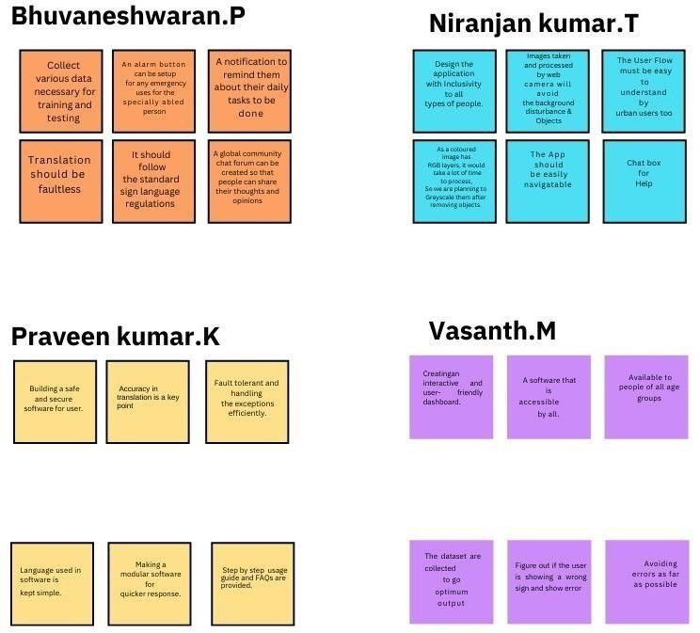

**DivyaBharathi.R**

**Gohulavarsini.k**

**Boomija.M**

**IDEA PRIORTIIZATION:**

The App should easil

navigatatbab llee

Collect various data necessary for training

and testing

Avoiding errors as far as possible

modular software for quick response.

The App should easily navigable



**FEASIBLITY**